AUTISM RESEARCH STUDY

Do you:
- Have a child with autism who has a sibling without autism between ages 5 and 14?
- Want to better understand how your child without autism is coping?
- Want to further research on families with a child with autism?

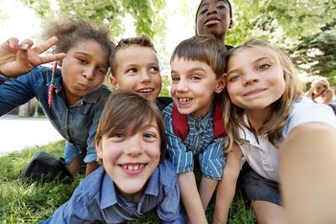
Participation includes parent questionnaires, a brief parent interview, and a brief interview with a NON diagnosed sibling of a child with autism.
Children are compensated for their participation with a $20 gift card.

If interested please email Jesseca at:
Jesseca.perlman@gmail.com

